1. **Overview** 
   1. **Introduction:** This document cover the contributor ( Insurees ) registration, claim and Health facility.
2. **To Register the Contributor:**  Follow the flowing steps:
   1. Firstly login the application.

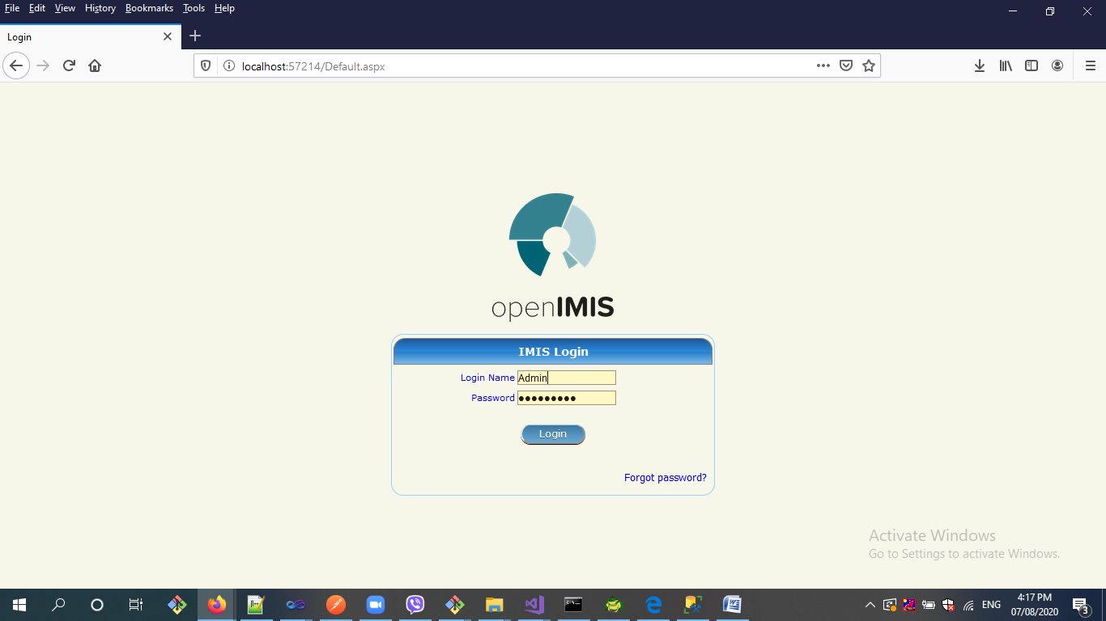

* 1. After login it display home page like below:

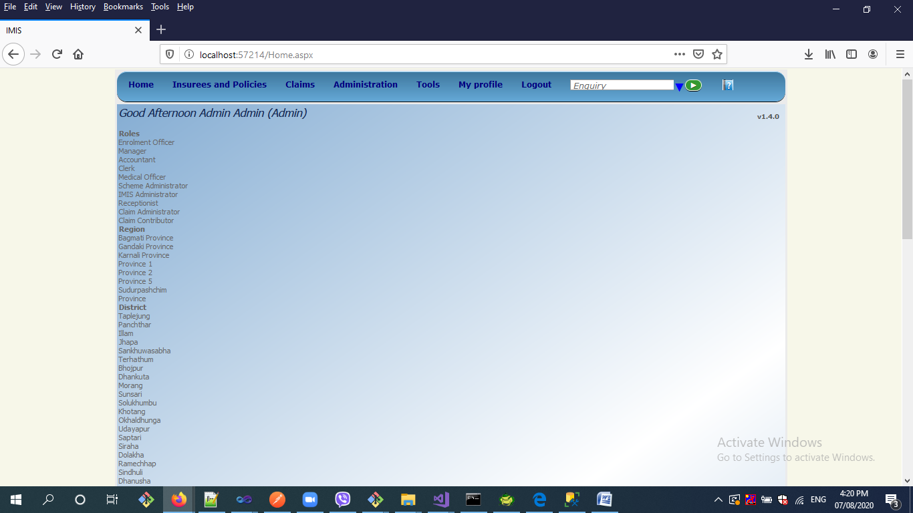

* 1. Then go to the **Insurees and Policies** Menu and click on **Add SSF Contributor.** When we click on it then it will open the following form:

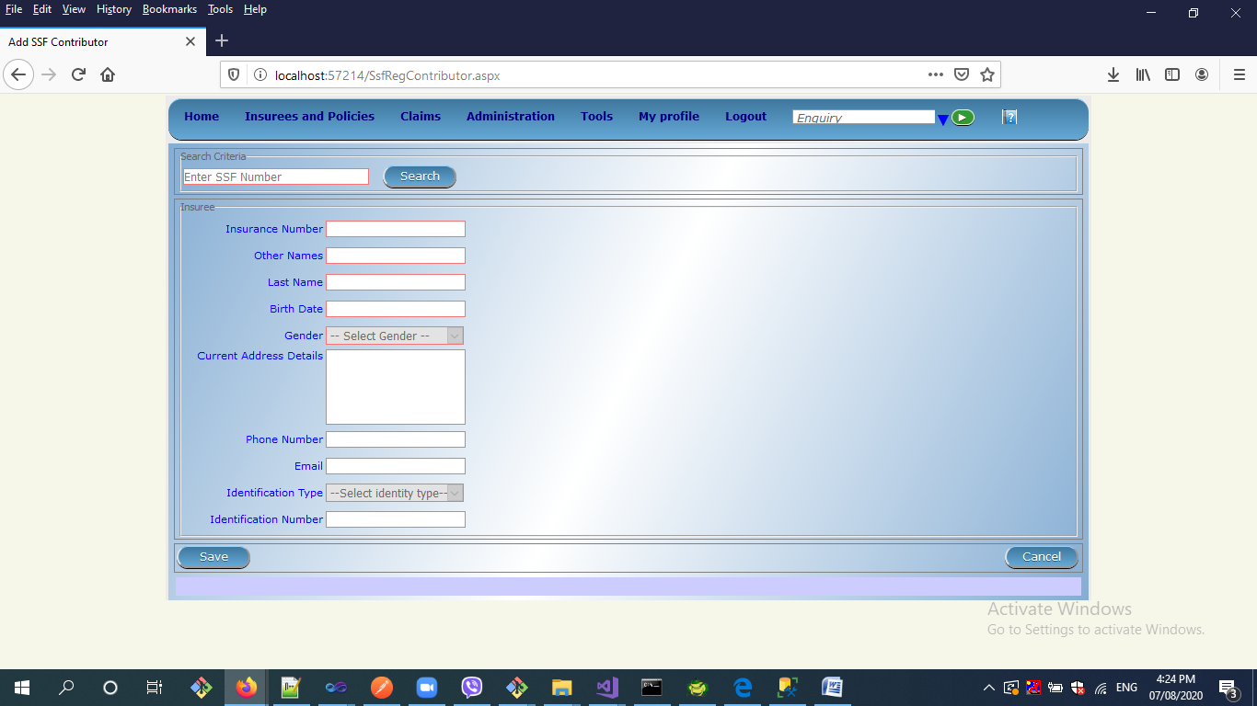

2.4. thereafter, enter SSF Number and clink on Search button . After Clicking on Search Button, It will get contributor information from sosys server like:

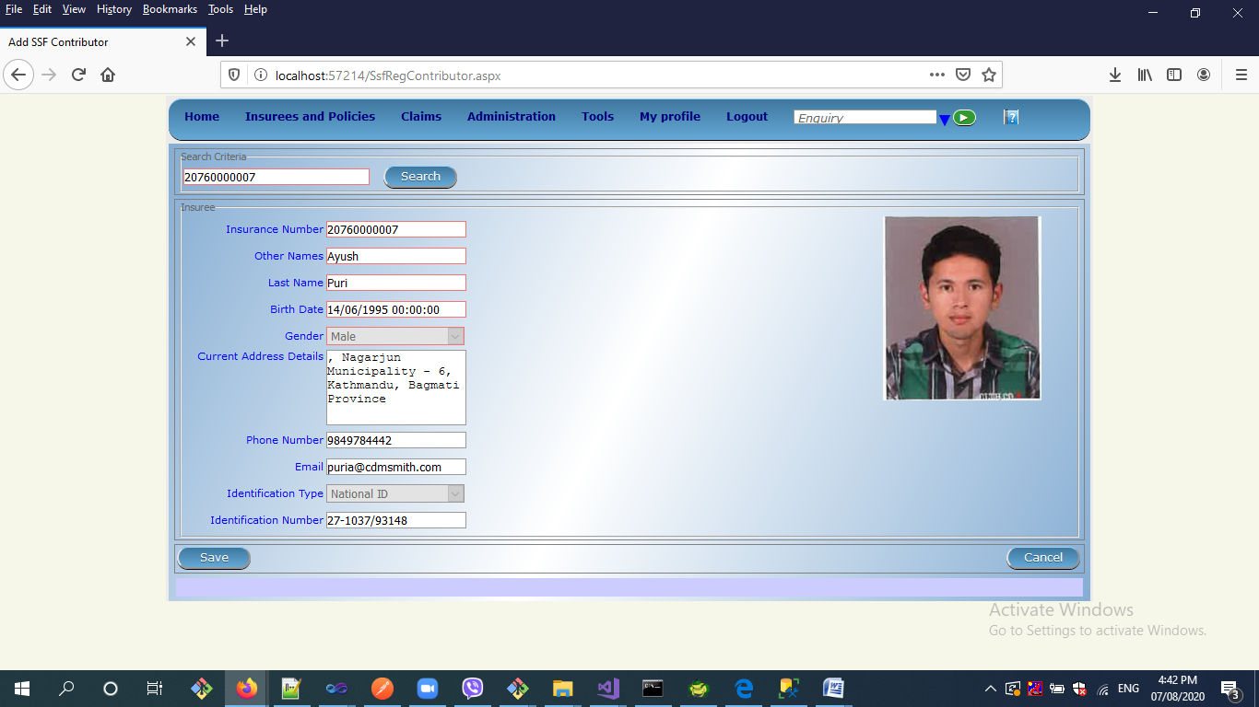

2.5. And finally click on save button. After saving It will display alert window like:

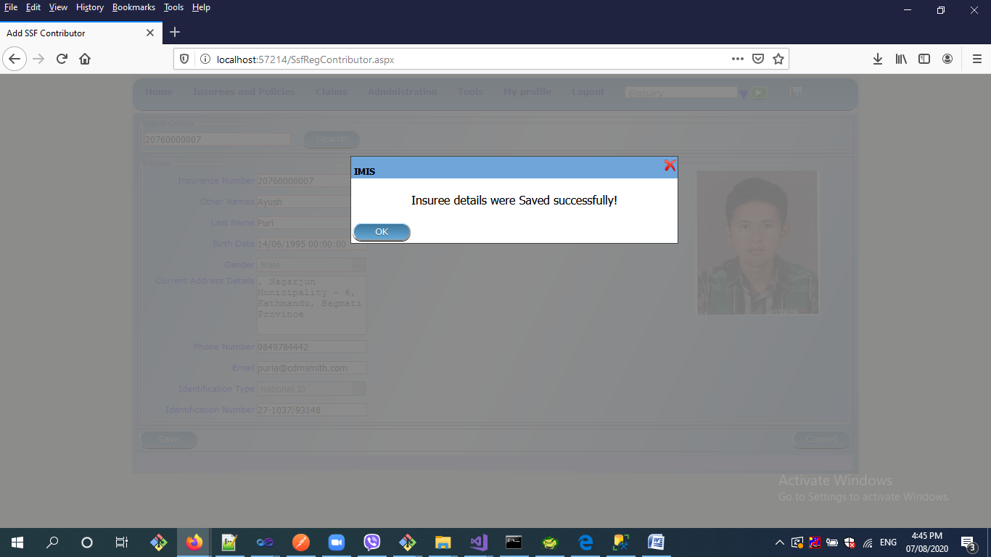.

1. **claim** and **Health facility:**  To Claim Module and Health facility module , Please see the old user manual that is provided by GIZ Team.

**Note:** A table that is used in Open IMIS Named as **dbo.tblSSFSchemes**

|  |  |  |
| --- | --- | --- |
| Column Name | Data Type | Allow Nulls |
| SCH_ID | int | N |
| SCH_NAME | nvarchar(100) | N |
| SCH_NAME_ENG | nvarchar(100) | Y |
| VISIT_TYPE | nvarchar(10) | N |
| ENTRY_BY | nvarchar(30) | N |
| ENTRY_BY | date | N |
| R_STATUS | nvarchar(1) | N |
| SCHAPP_ID | int | N |